**Example:**

**[Running Title eg:** Effects of sleep on postpartum depression]

**[The problem/issue]** [*eg. Postpartum depression (PPD) is a serious form of depression that affects 1 in 8 new mothers; yet current healthcare practice lacks appropriate intervention strategies to improve or prevent the condition.*

**[Need for research]** *[eg. Sleep deprivation is strongly associated with development of various mental conditions, including PPD, the effects of improved sleep through behavioral interventions on postpartum depression is not yet studied*]

**[ Purpose/Objective of Study <-> Research question]** *[ eg. In order to understand the effects of sleep deprivation on postpartum depression, we asked whether improving sleep in new moms can ameliorate or prevent postpartum depression.]*

**[ Study description]** *[eg. In order to answer this question we designed an experimental study, where we recruited 100 expecting mothers and randomly divided them into intervention and control groups. We measured naturally occuring sleep in both groups through the use of activity trackers. Based on these measurements and the optimal sleep levels, we provided the experimental group recommendations to improve their sleep. The control group did not receive any recommendations on their sleep, instead they received same level of interaction on a different content. We monitored the affective state (depression scores) of both groups at 2, 4, 6 and 12 months postpartum. We also measured blood cortisol levels at 2 and 12 months postpartum period for both groups.]*

**[Results]** *[ eg. Between group comparisons showed that monthly sleep quality and quantity increased, depression scores at 4, 6 and 12 months postpartum periods decreased, and c) blood cortisol levels at 2 and 12 month postpartum periods significantly decreased for experimental group (2 sample 1-sided t-test, p<0.001, power:0.9). We also found a strong negative correlation between cumulative sleep quality and depression scores, a strong positive correlation between blood cortisol and depression scores. ]*

**[Significance]** *[eg. Our results strongly suggest that sleep-based simple interventions may improve and prevent postpartum depression. Our study was the first in incorporating a sleep-focused behavioral intervention into postpartum period and looking into its effects on treatment and/or prevention of postpartum depression and stress. ]*

Mock Figure 1:

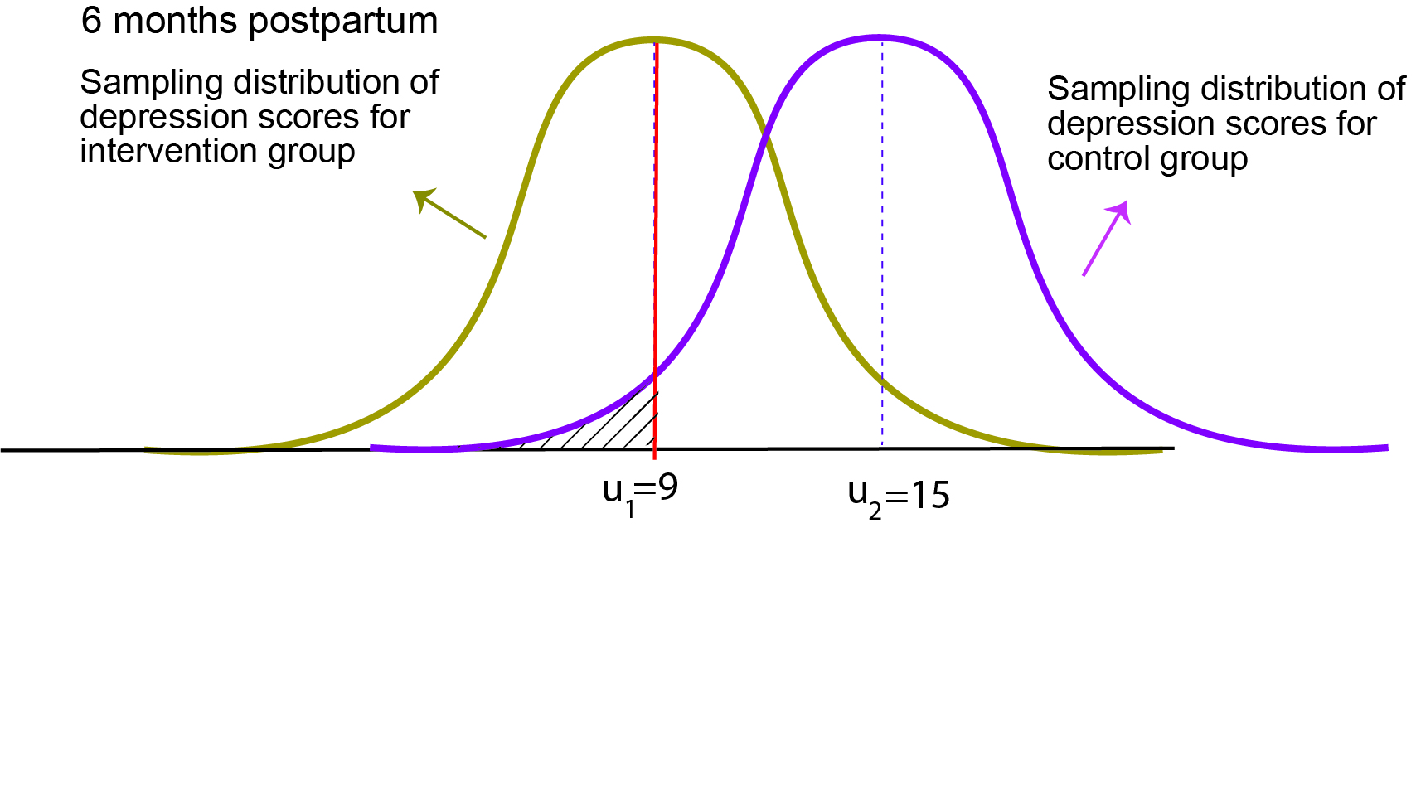

Mock Figure 2:

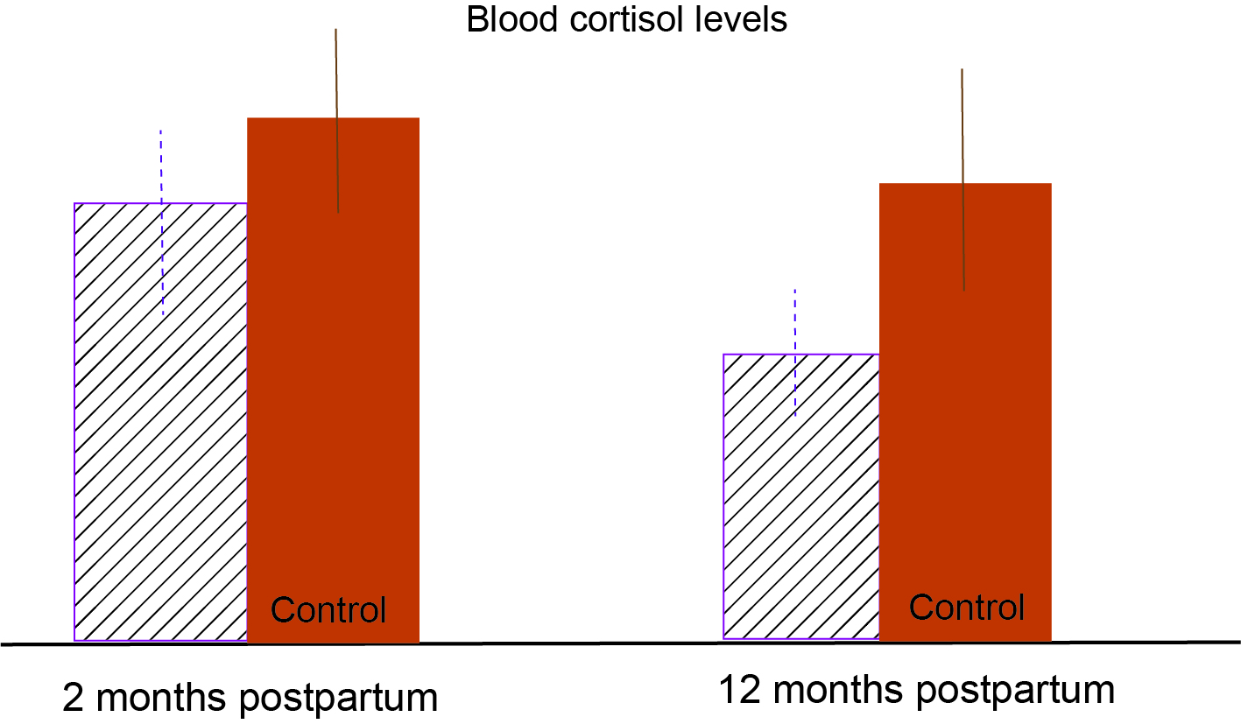

**Please copy/paste this page at the bottom and start writing….**

-------------------------------------------------------------------------------------------------------------------------------

**Name:**

**Title**

**Problem**

**Need**

**Purpose / Objective of the study <-> Research question**

**Study description**

**Results**

**Significance**

-------------------------------------------------------------------------------------------------------------------------------